CORE VALUES OF

FIRST BAPTIST CHURCH GRANADA HILLS

1. We value FAITH because it is foundational to all that we stand for as a church. Faith is absolute trust in God and believing that the Bible is truth without any mixture of error.

The best definition of faith is found in Hebrews 11:1 “Now faith is being sure of what we hope for and certain of what we do not see.”

We hold to this value because we can not have forgiveness for our sins and salvation for our souls apart from faith.

The scriptures tell us: “For it is by grace you have been saved, through faith-and this not from yourselves, it is the gift of God.” Ephesians 2:8

“And without faith it is impossible to please God, because anyone who comes to him must believe that he exists and that he rewards those who earnestly seek him.” Hebrews 11:6

CORE VALUES OF

FIRST BAPTIST CHURCH GRANADA HILLS

2. We value OBEDIENCE because it is the process of putting faith into action. Obedience for believers is obeying the Word of God and doing the will of God.

Obedience to God’s Word is our badge of discipleship. Obeying our Lord gives evidence that we are truly His
children and that we have been born again into His family.

The scriptures tell us: “But Samuel replied: “Does the Lord delight in burnt offerings and sacrifice as much as in obeying the voice of the Lord? To obey is better than sacrifice, and to heed is better than the fat of rams.” I Samuel 15:22

Jesus said: “If you love me, you will obey what I command.” John 14:15

CORE VALUES OF

FIRST BAPTIST CHURCH GRANADA HILLS

- We value INTEGRITY because without integrity we can
not posses a strong witness for Christ. By possessing
integrity we are able to match our outward actions to our
inward Christian values.

We hold to this value because we can not be effective
ambassadors for Jesus Christ unless we possess moral
integrity and demonstrate honesty in our dealings with others.

“The integrity of the upright guides them, but the unfaithful
are destroyed by their duplicity.” Proverbs 11:3

“In your teaching show integrity, seriousness and
soundness of speech that cannot be condemned, so that
those who oppose you may be ashamed because they have
nothing bad to say about us.” Titus 2: 7b-8

CORE VALUES OF

FIRST BAPTIST CHURCH GRANADA HILLS

- We value FAMILY because our family is the first and greatest earthly gift that God has given to us. We have a unique responsibility to love, cherish, help, encourage, pray for and mentor members of our family.

We hold to this value because we recognize our family is a unique gift from God.

As Christians we recognize that our brothers and sisters in the faith are a part of our extended family the church.

“If anyone does not provide for his relatives, and especially for his immediate family, he has denied the faith and is worse than an unbeliever.” I Timothy 5:8

“Therefore, as we have opportunity, let us do good to all people, especially to those who belong to the family of believers.” Galatians 6:10

CORE VALUES OF

FIRST BAPTIST CHURCH GRANADA HILLS

- We value FORGIVENESS because it is foundational to our relationship with God. This value means that we understand that we are to forgive others in direct proportion to the way that God has forgiven us.

We hold to this value because as children of God we have experienced the love, mercy and forgiveness of God.

“Do not judge, and you will not be judged. Do not condemn and you will not be condemned. Forgive and you will be forgiven.” Luke 6:37

“For if you forgive men when they sin against you, your heavenly Father will also forgive you. But if you do not forgive men their sins, your Father will not forgive your sins.” Matthew 6:14-15

CORE VALUES OF

FIRST BAPTIST CHURCH GRANADA HILLS

- We value EVANGELISM because it is God’s will for all who will open their hearts up to Jesus Christ as Lord and Savior to have forgiveness for their sins and salvation for their souls.

We hold to this value because Jesus Christ has commissioned His followers to take the good news of salvation to the entire world . Evangelism is sharing Jesus Christ in the power of the Holy Spirit and leaving the results to God.

“But as many as received Him, to them He gave the right to become children of God, to those who believe in His name.”
John 1:12 (NKJ)

“Al authority in heaven and on earth has been given to me. Therefore go and make disciples of all nations, baptizing them in the name of the Father and of the Son and of the Holy Spirit, and teaching them to obey everything I have commanded you. And surely I am with you always, to the very end of the age.” Matthew 28: 18b-20

All scripture quotations have been from the New International Version of the Bible except where noted.

FIRST BAPTIST CHURCH GRANADA HILLS
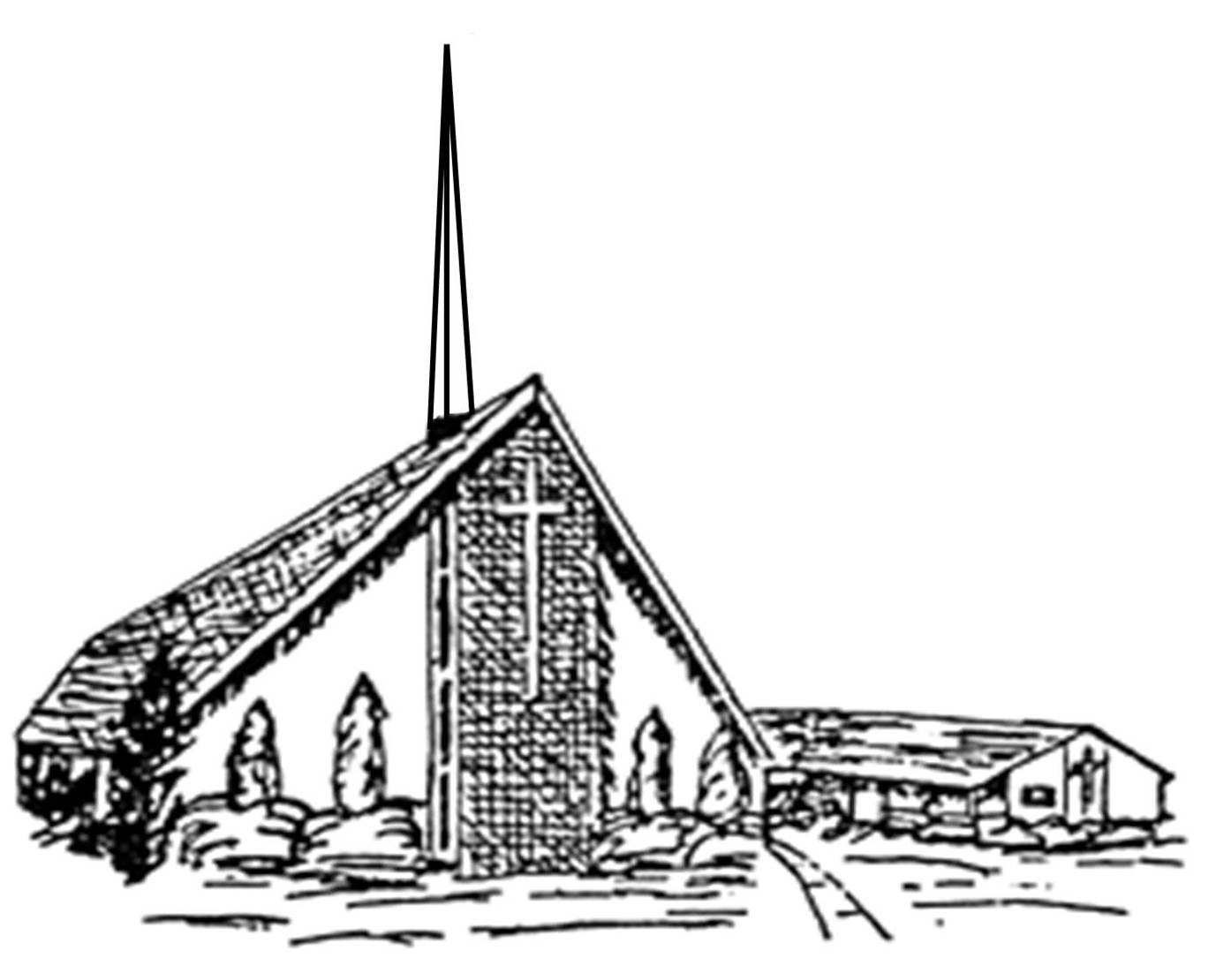

CHURCH HEALTH ASSESSMENT PLAN

Mission Statement

Vision Statement

Core Values

MSSION STATEMENT

The mission of First Baptist Church of Granada Hills is to
love the Lord with all that we are by being obedient to the
Lord’s example and to fulfill the Great Commission.

VISION STATEMENT

- We envision our people humbling themselves before the
Lord in Praise and Worship so that the presence of the Lord
is experienced. We will obey and faithfully trust the Lord.

- We envision the church body reaching out into the community
to share the Lord’s love with wisdom, integrity and truth. We
will love them and each other through fellowship, prayer and
evangelism.

- We desire to raise up strong, godly yet humble servant leaders
who will guide us with sound Biblical values in order to equip
the believers for the Lord’s work and therefore spiritual
maturity.

- We desire that every member be a light and example of Jesus to
other members and unsaved people with continued outreach
and strong support for mission activities locally and throughout
the world.

Dear fellow member:

This booklet was created with the purpose of keeping fresh in

our memories and our hearts what the First Baptist Church is all

about: its mission statement, vision statement and core values.

We encourage you to go back every so often to these pages to

renew your own commitment to these principals as we move

forward together as a congregation.

May , 2007

